Install nginx and run nginx on port number 81.
Objective Install the Nginx web server and configure it to listen on port 81 instead of the default HTTP port (80).

Step1 : launch one instance in AWS. And connect to the EC2 instance.

Step 2: then open the downloaded .pem file in the windows and open a gitbash here

Step3 : connect it with ssh using ssh -i nikhil.pem ec2-user@52.14.202.70 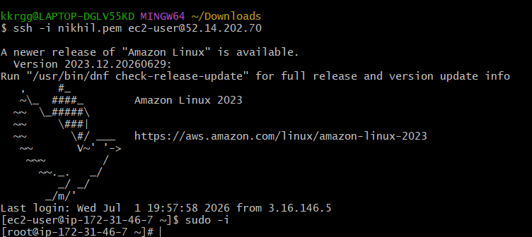

Step4 : install inginx using command sudo yum install nginx -y 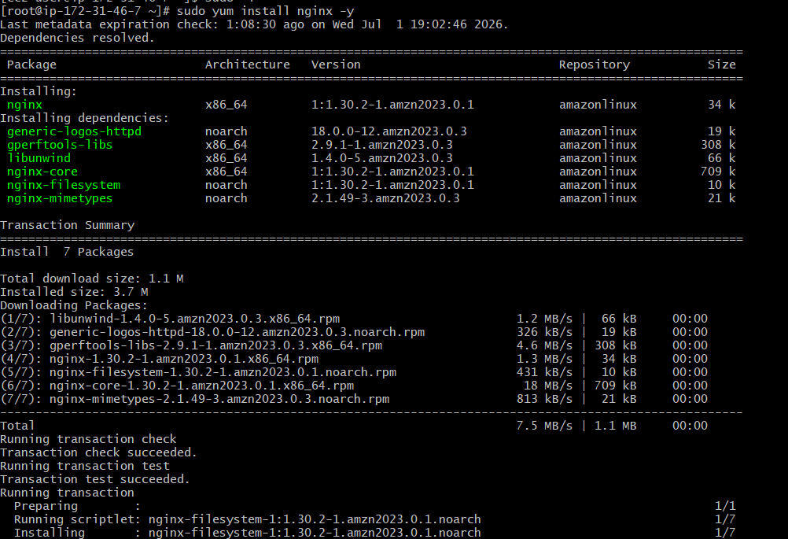

Step 5: start the service nginx

Step 6: enable the service

Step 7: check the status 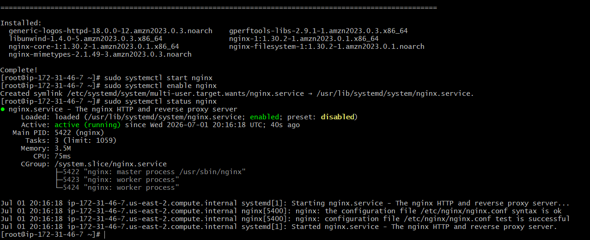
- Step 7: Change Nginx to listen on port 81
commands used are
sudo vi /etc/nginx/nginx.conf
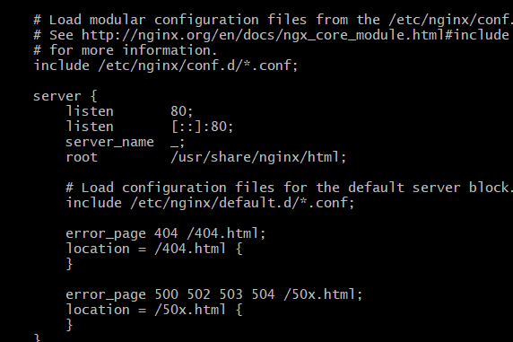
change the port number to 81 then execute the command
sudo cat /etc/nginx/nginx.conf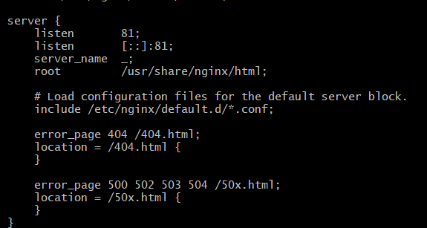
step 8: restart the nginx service
step 9: browse the public ip with portnumber 81
output shows as 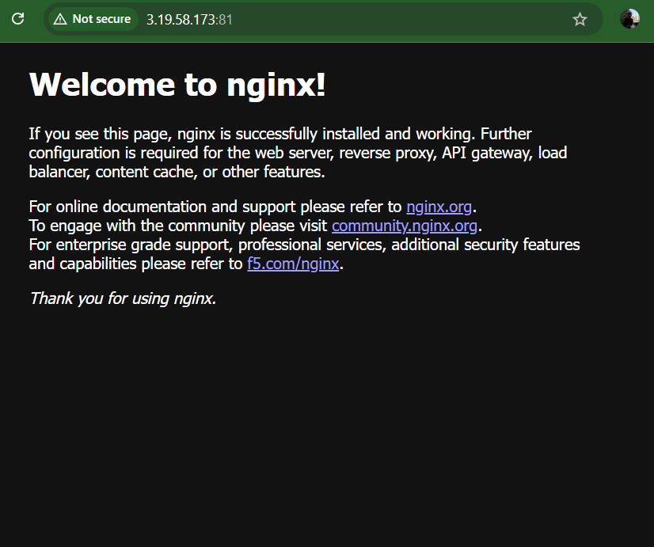

- Deploy a sample index.html file on nginx.
Objective : To deploy a webpage on nginx
step1. Navigate to deployment path /usr/share/nginx/html
step2. open Vi file and replace the text Welcome to nginx with Welcome to Devops session
step3. Fresh the webpage and check for output
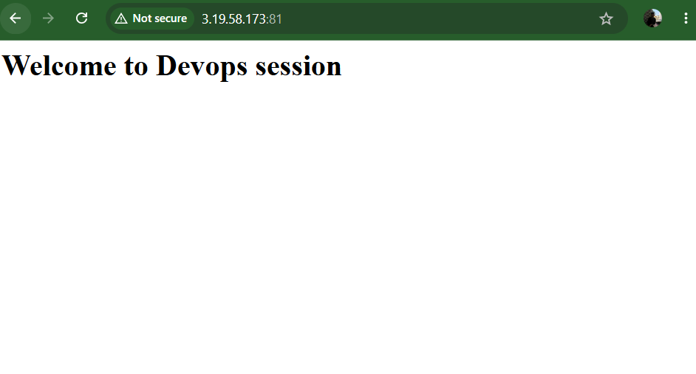
3. Install Apache and run Apache on port number 82
Ojective : need to install apache and run the apache on required port number 2
step 1: install apache using command yum install httpd
step 2: check whether apache is running or not. If not active then start the service and check once again using systemctl status httpd
commands used
1.systemctl status httpd
2. systemctl start httpd 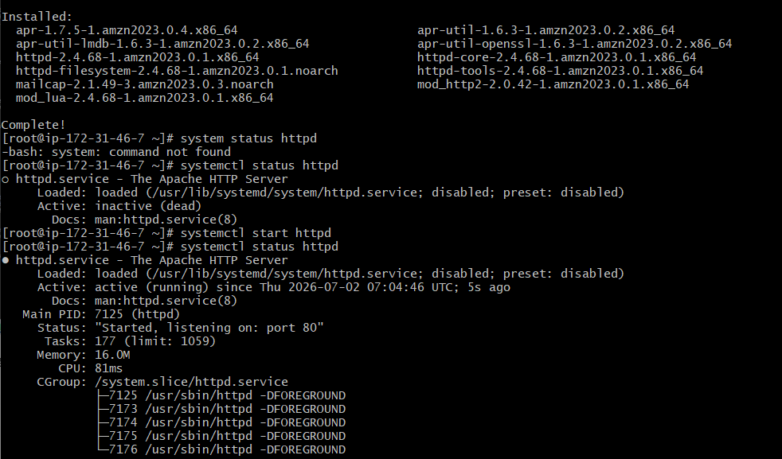
step 3: check it on browser with public id
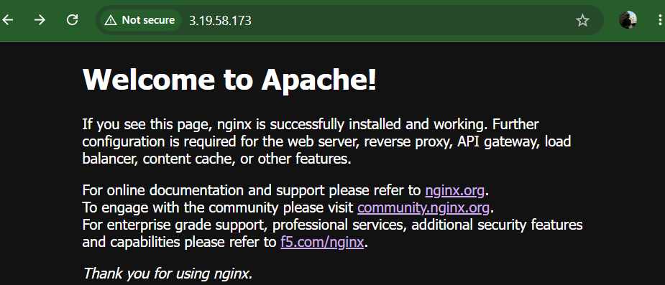
step 4: need to change the port number 80 to 82
commands used are sudo vi /etc/httpd/httpd.conf
cat vi /etc/httpd/httpd.conf
Step 5: restart the service
Step 6: browse it with public ip 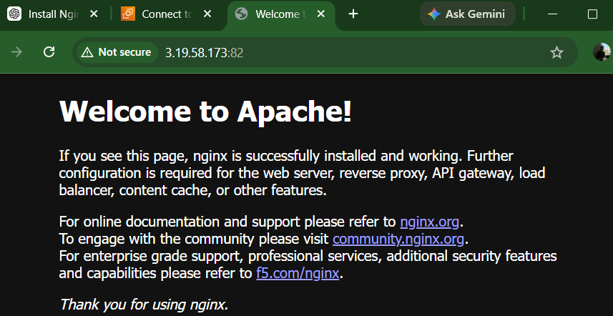

- Deploy a sample index.html file on Apache.
Objective : To deploy a webpage on Apache
step1. Navigate to deployment path /var/www/html/
step2. open Vi file and replace the text.
step3. Fresh the webpage and check for output.
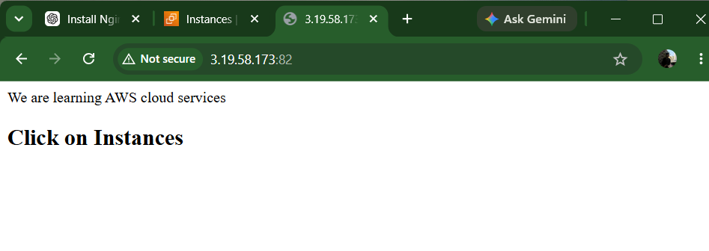
- Install Apache tomcat on port number 8082
Objective : To install apache tomcat that run on required port number.
step1 : Connect to ec2 instances.
step2 : In gitbash use command ssh -i nikhil.pem ec2-user@3.19.58.173.
step3 : install java using sudo dnf install java-17-amazon-corretto-devel -y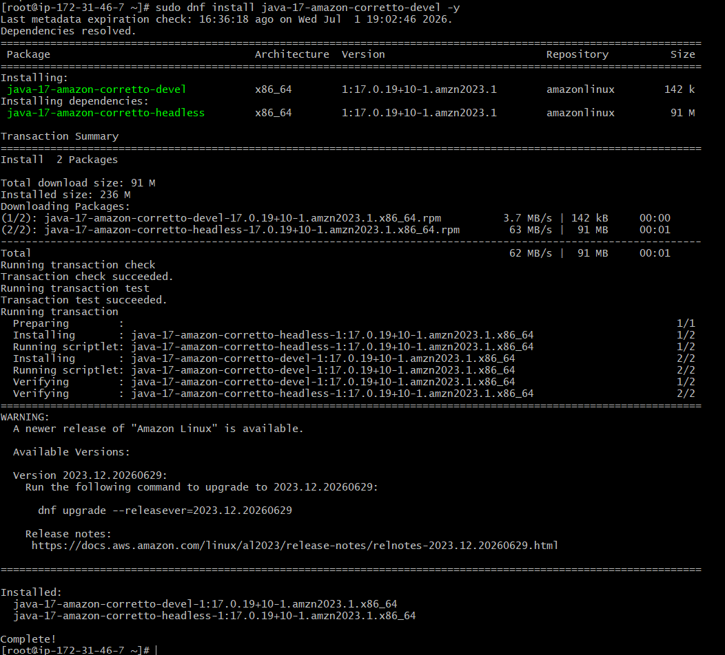
step 4: download the java
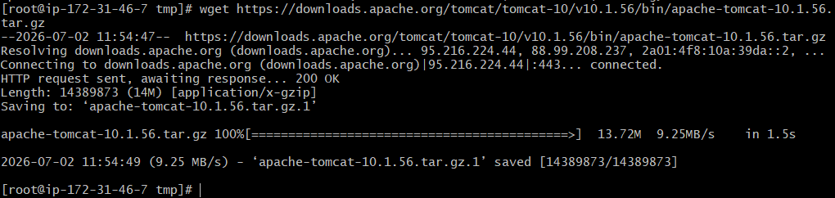
used command as wget https://downloads.apache.org/tomcat/tomcat-10/v10.1.56/bin/apache-tomcat-10.1.56.tar.gz
step 5: Extract the file
since the file is downloaded as zip file we need to extract this using sudo tar -xzf apache-tomcat-10.1.56.tar.gz
step 6: Save the extracted file with name using sudo mv apache-tomcat 10.1.56 tomcat
step 7: start the tomcat server check the status whether running or not .
step 8: browse it with public ip
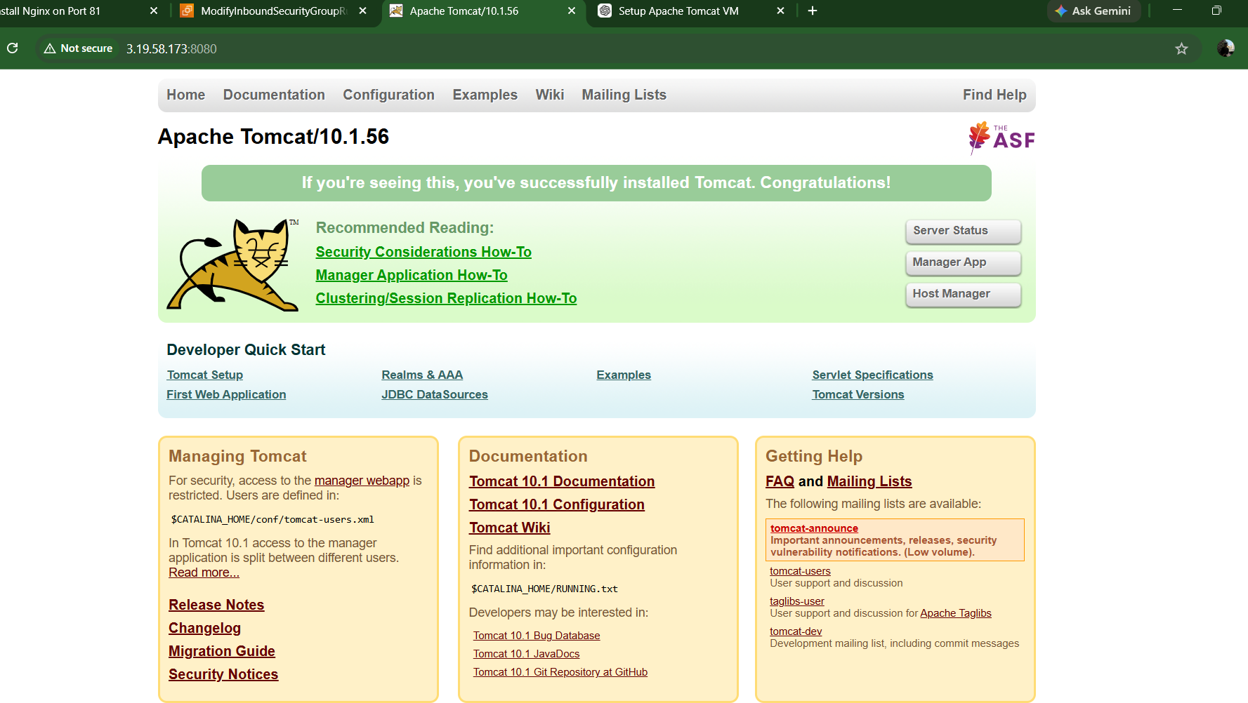
step 9: Change the port number to 8082
Since your Tomcat is working perfectly on port 8080, we need to change the Tomcat connector port to 8082. We need to open vi editor sudo vi /opt/tomcat/conf/server.xml.
Change the text 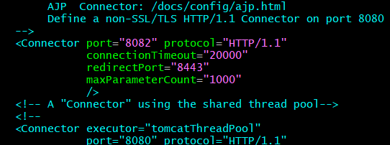
step 10: restart the service and check status
step 11: browse with 8082 port number and check output
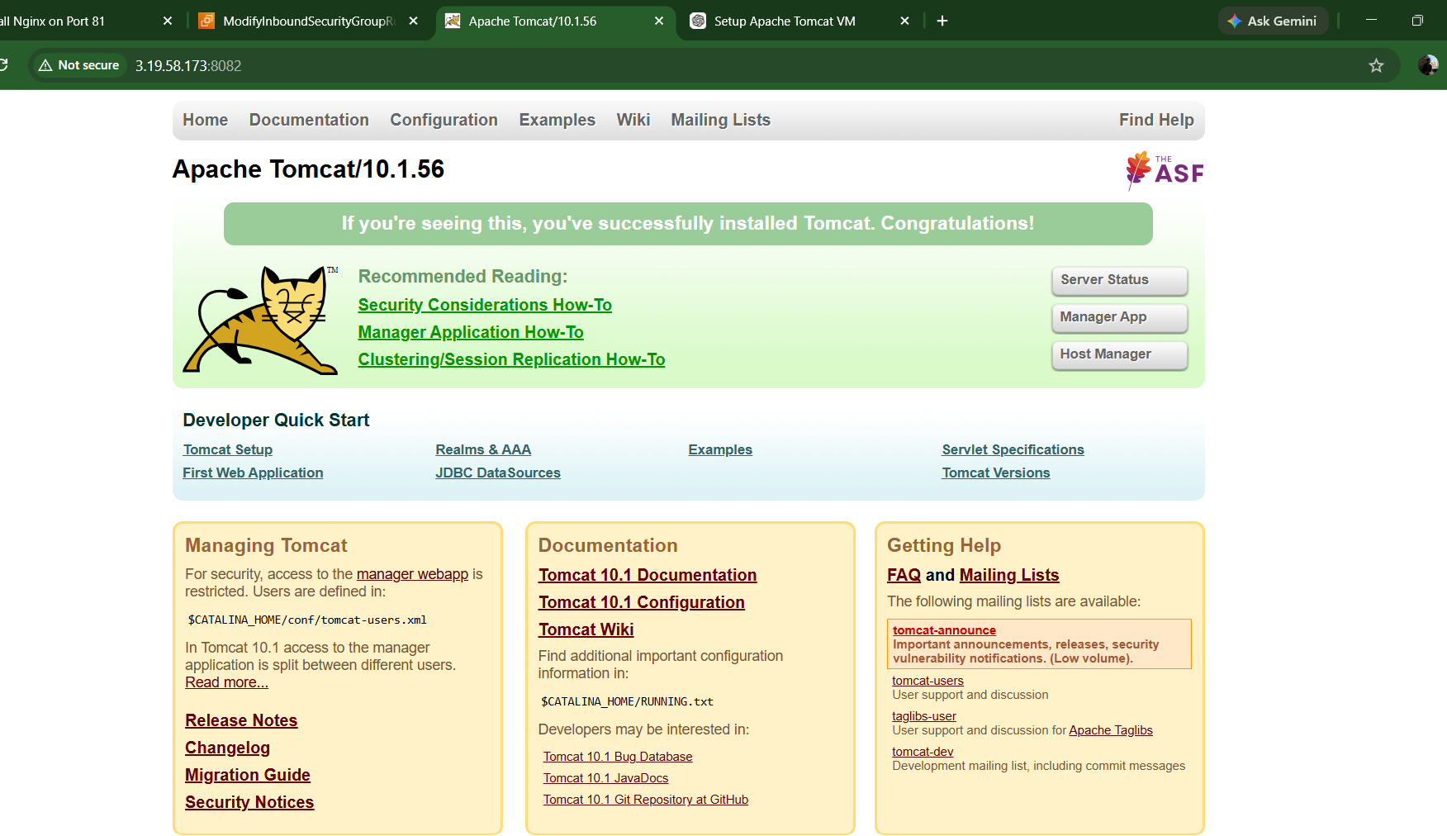
- Deploy a sample app on webapps
Ojective : Deploy a sample Java web application on Apache Tomcat and access it through a web browser.
step 1: change to the tomcat webapps directory using command as cd /opt/tomcat/webapps
step 2:download a sample war file. wget https://tomcat.apache.org/tomcat-10.1-doc/appdev/sample/sample.war
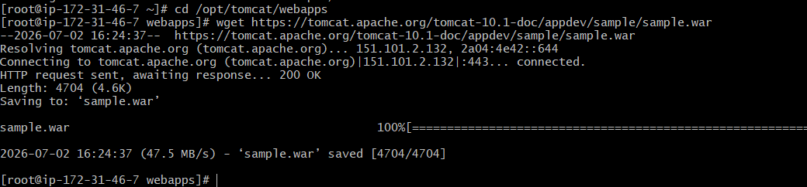
step 3: restart the service and check it. sudo systemctl status tomcat
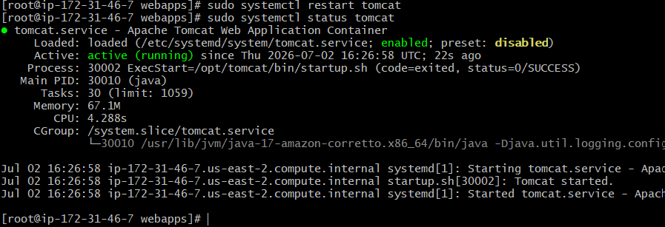
step 4: Browse it in web using public ip
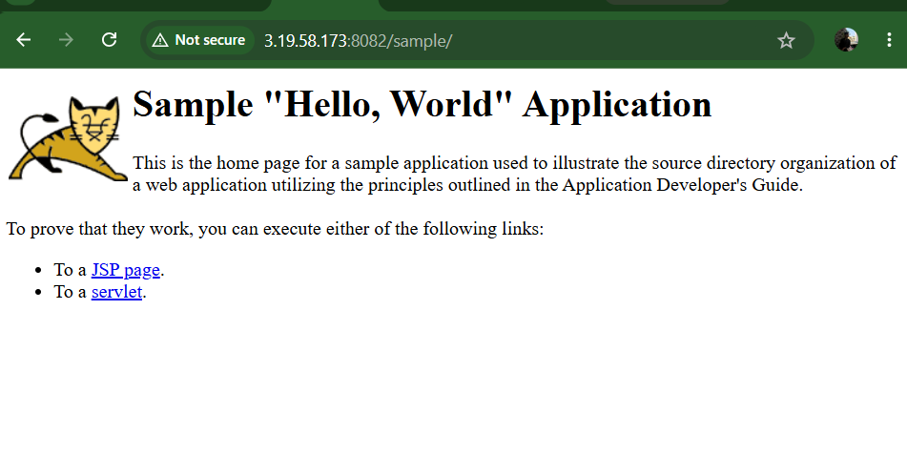
- Create a tomcat.service file for tomcat.
locate the file system directory.
create a new directory name service.xml
lets get the service file content from web and replace it new text.
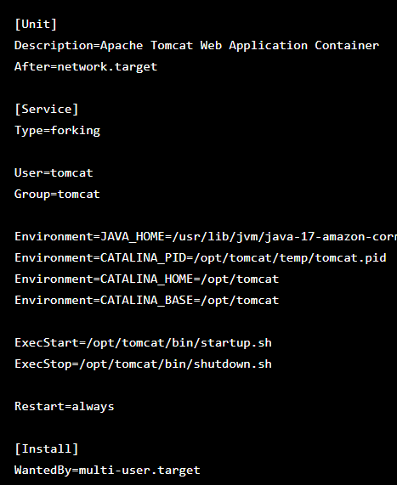
lets restart the service and enable it and also check for status
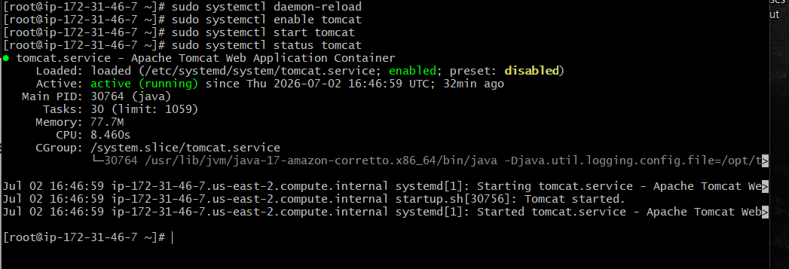
finally check it on web
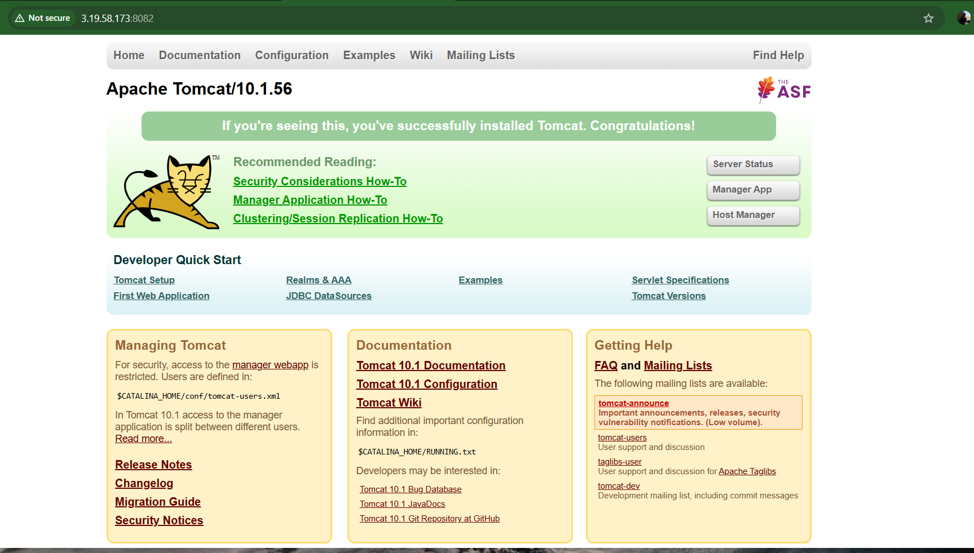
- Configure HA Proxy serve
create 3 EC2 instances:
Instance Name | Purpose | Software
haproxy-server | Load Balancer | HAProxy
nginx-server-1 | Backend Server | Nginx
nginx-server-2 | Backend Server | Nginx

Architecture
Internet
│
│
HAProxy Server (Port 80)
Public IP
│
┌─────────────┴─────────────┐
│ │
▼ ▼
Nginx Server 1 Nginx Server 2
Port 80 Port 80

Part 1: AWS Setup
- Launch 3 Amazon Linux 2023 EC2 instances
- Configure Security Groups
- Connect using gitbash 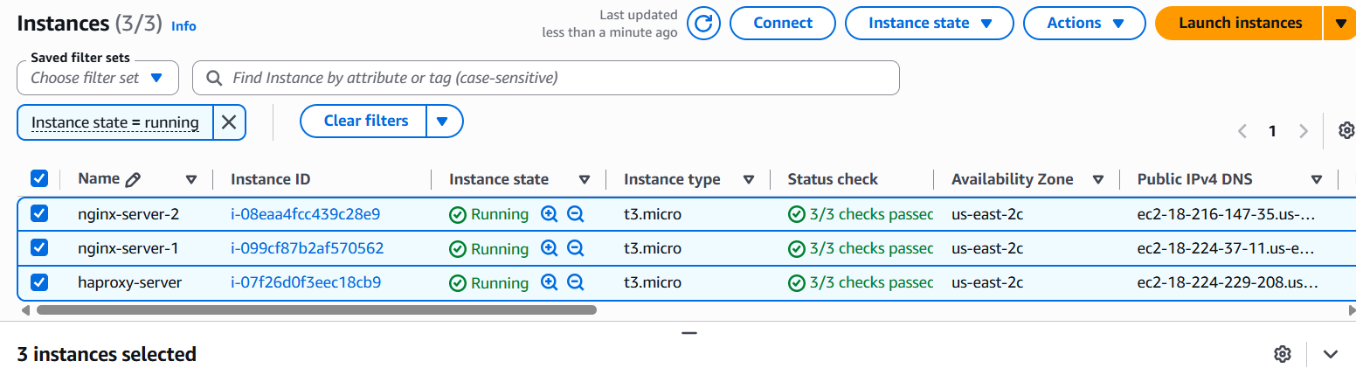

Part 2: Configure Nginx Server 1
- Install Nginx
- Start and enable the service
- Create a custom web page 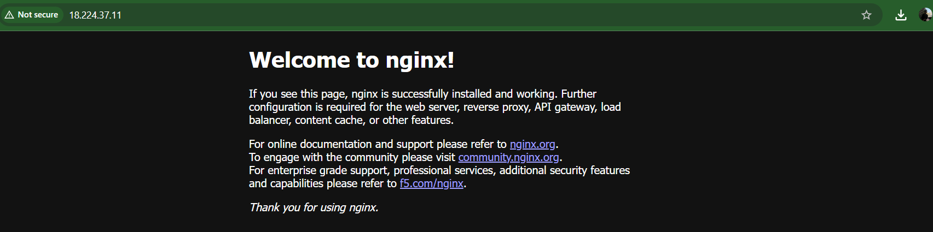
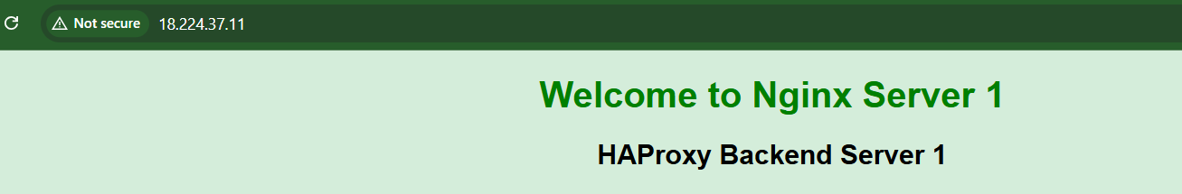

Part 3: Configure Nginx Server 2
- Install Nginx
- Start and enable the service
- Create a different custom web page 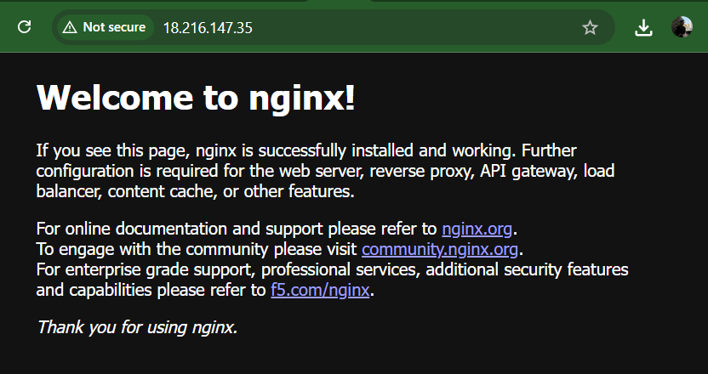
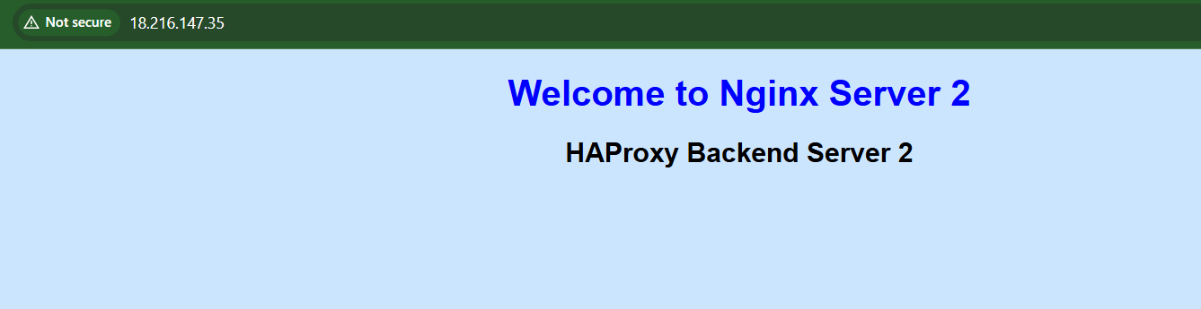

Part 4: Configure HAProxy
- Install HAProxy
- Edit haproxy.cfg
- Add both Nginx servers as backend servers
- Validate the configuration
- Start the HAProxy service

Part 5: Testing
- Access the HAProxy public IP in a browser 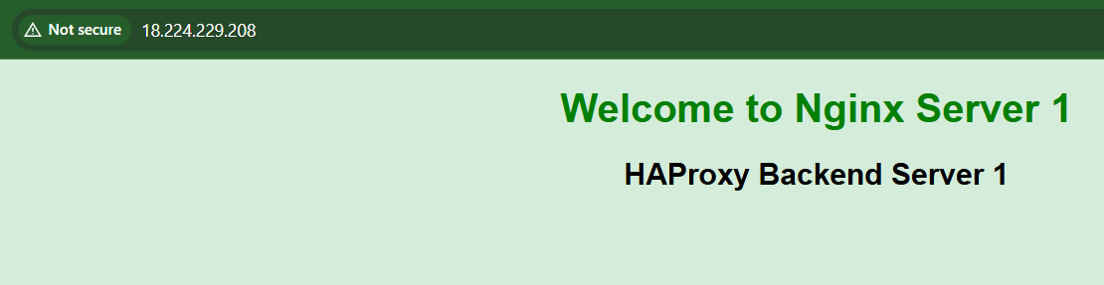
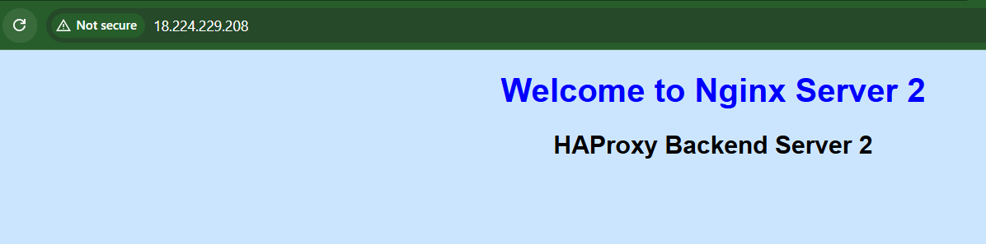
- Refresh the page to observe round-robin load balancing
so we came to know that
Client Browser
│
│
http://18.224.229.208
│
HAProxy Server
(18.224.229.208)
│
┌───────────────┴───────────────┐
│ │
▼ ▼
nginx-server-1 nginx-server-2
172.31.39.156 172.31.42.100
"Welcome to "Welcome to
Nginx Server 1" Nginx Server 2"
When you refresh the browser:
- ✅ Request 1 → Nginx Server 1
- ✅ Request 2 → Nginx Server 2
- ✅ Request 3 → Nginx Server 1
- ✅ Request 4 → Nginx Server 2
This confirms Round Robin Load Balancing is working.

- Stop one Nginx server to verify automatic failover

Key learnings
- Install and configure HAProxy.
- Configure backend servers.
- Use the Round Robin load-balancing algorithm.
- Configure health checks.
- Verify automatic failover when a backend server becomes unavailable.

